Dumpster Fire UI Document

General Overview
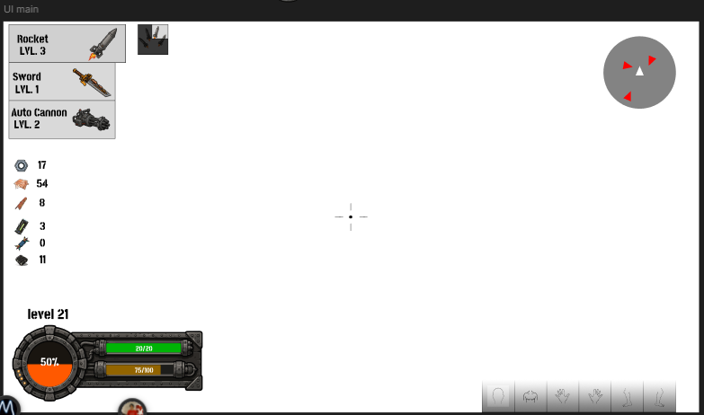
(First UI Wireframe made)
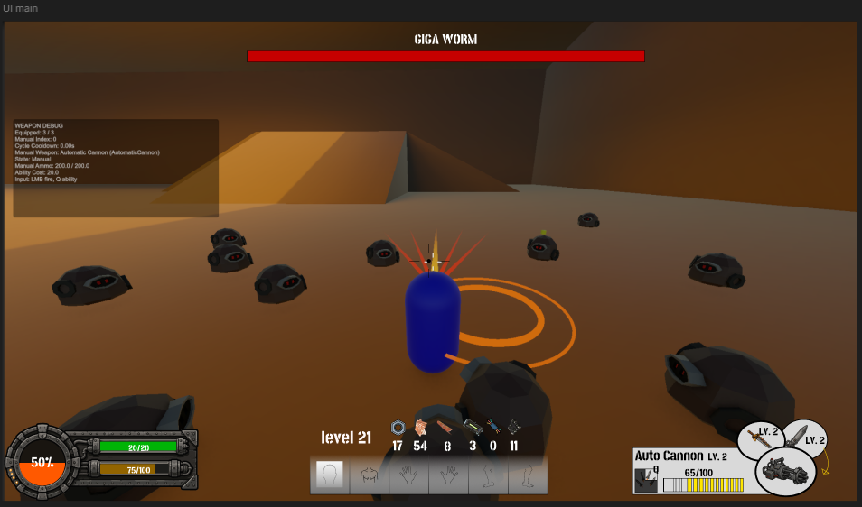(Actual UI Wireframe, not in a game plactualy)
The main gameplay interface is designed to communicate the player’s combat status, available resources, equipped weapon, progression and enemy information without excessively obstructing the gameplay area.
Most interface elements are positioned around the borders of the screen, leaving the central area available for movement, aiming and enemy visibility.

Boss Health Bar
The boss health bar is located at the top center of the screen.

Purpose
Its main function is to display the remaining health of the current boss enemy.

Visual Elements
- Boss name.
- Horizontal health bar.
- Red health indicator.
- Dark background used to show missing health.

Behavior
The red bar decreases from right to left as the boss receives damage.
The boss name remains visible above the bar so that the player can immediately identify the main enemy of the encounter.
This element is only displayed during boss encounters or special combat events.

Player Status Module
The player status module is located in the bottom-left corner of the screen.
It contains the player’s most important survival-related information.

Health Bar
The green horizontal bar displays the player’s current health.
The numerical value is shown inside the bar using the following format:
Current Health / Maximum Health
Example:
20 / 20

Behavior
The health value decreases when the player receives damage and increases when health is restored.
The green color communicates that the player is currently in a stable condition.
When the player reaches a critical amount of health, the interface may provide additional feedback such as:
- Changing the bar color.
- Flashing the health indicator.
- Adding a red screen effect.
- Playing a warning sound.
- Animating the mechanical frame.

Experience Bar
The lower horizontal bar displays the player character’s current experience points and progression toward the next level.
The numerical value is displayed using the following format:
Current Experience / Experience Required
Example:
75 / 100

Circular Percentage Indicator

Overheat Indicator
The circular percentage indicator represents the current level of the Overheat system, one of the main difficulty-progression mechanics of the game.
The percentage shows how close the Overheat meter is to reaching its maximum value.
Example:
50%

Level and Experience Information
The player’s current level is displayed near the bottom center of the screen.
Example:
Level 21

Purpose
This element communicates the player’s current progression level.

Resource Counters
A group of icons and numerical values is displayed near the bottom center of the screen.
Each icon represents a resource, item, ammunition type or collectible obtained during the current game session.

Structure
Each resource indicator contains:
- A visual icon.
- A numerical quantity.
- A fixed position within the resource row.

Purpose
The counters allow the player to monitor their available materials and understand which resources can be spent, collected or used during gameplay.
Ability or Upgrade Slots
A horizontal group of rectangular slots is located at the bottom center of the screen.
These slots represent the passive abilities upgrades or body modifications currently owned by the player

Slot Information
Each slot may contain:
- Ability icon.
- Upgrade icon.
- Ability level.
- Cooldown overlay.
- Locked-state indicator.
- Selection highlight.

Current Visual State
In the current version, some slots appear inactive or without fully implemented icons.
Inactive slots use a neutral or desaturated visual appearance.

Weapon Information Module
The equipped weapon module is located in the bottom-right corner of the screen.

Purpose
This module displays the weapon currently being used by the player and its main gameplay statistics.

Displayed Information
- Weapon name.
- Weapon level.
- Weapon icon.
- Current ammunition.
- Maximum ammunition.
- Ammunition bar.
- Secondary weapon indicators.
- Weapon switching information.

Weapon Name and Level
The name of the equipped weapon is displayed at the top of the module.
Example:
Auto Cannon LV. 2
This allows the player to immediately identify the selected weapon and its upgrade level.

Ammunition Counter
The ammunition value is displayed numerically.
Example:
65 / 100
The first number represents the current ammunition, while the second represents the maximum ammunition capacity.

Ammunition Bar
A segmented yellow bar provides a visual representation of the remaining ammunition.
The segmented design allows the player to estimate the available ammunition quickly without reading the numerical value.

Weapon Icon
The equipped weapon is represented by an illustrated icon inside a circular mechanical frame.
The icon reinforces weapon recognition and allows the player to identify the equipped weapon through its silhouette.

Secondary Weapon Indicators
Two smaller circular indicators are positioned above the main weapon icon.
These elements represent additional weapons, secondary firing modes or weapon slots.
Each indicator may display:
- Weapon icon.
- Weapon level.
- Availability state.
- Selection state.
- Cooldown.
- Ammunition state.

Screen Distribution
The interface is divided into four main visual areas.

Top Center
Contains the boss health bar and boss name.

Bottom Left
Contains the player’s health, Experience and Overheat indicator.

Bottom Center
Contains the player level, collected resources and ability slots.

Bottom Right
Contains the equipped weapon, ammunition and secondary weapon information.

Center of the Screen
The center remains mostly free with a crosshair that changes between weapons.

